Module 12 – Location Graph

Exploratory Data Analysis

*In this section, you should perform some data analysis on the data provided to you. Please format your findings in a visually pleasing way and please be sure to include these cuts:*

* *Make a visual graph of your data on a map (coordinates should be within US borders)*
  + <https://mymaps.google.com/>
  + Find a map with latitude/longitude and place it approximately
  + Any alternative that gives the same effect

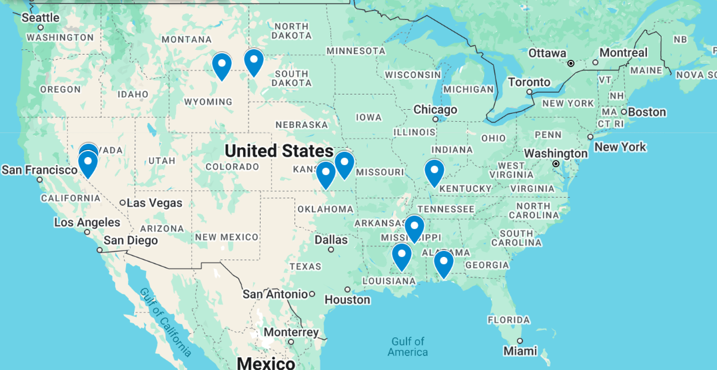

* Use your available data to determine a good starting coordinate for the DC
  + Should you use the average of the ranges of lat longs of the stores? Yes, average was used to determine starting point
  + Should you use the coordinates of the store furthest away from the current DC? No
  + Can you think of something better to use? No, I think this is the best I don’t know other alternatives, I am using best judgement here
  + Whatever you use, please record the optimal function with your starting coordinate to compare to your optimized model

Model Formulation

*Try to write the formulation of the model into here prior to implementing it in your Excel model. Be explicit with the definition of the decision variables, objective function, and constraints. Hint: Linking constraints aren’t needed since we are using Nonlinear GRG but refer to the associated PowerPoint in your data if you need help.*

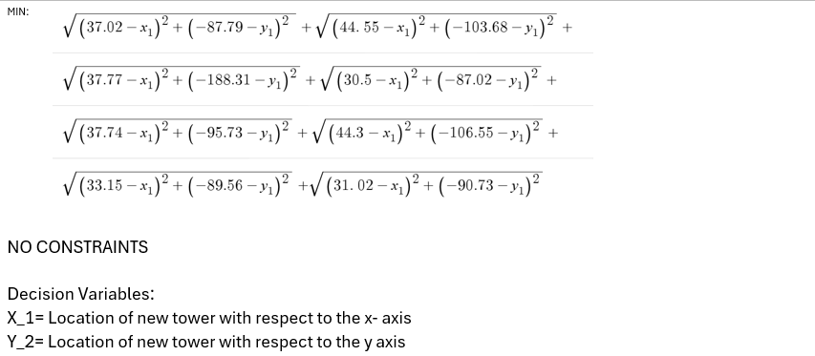

Model Optimized for Distance Reduction from DC to Store

*Implement your formulation into Excel and be sure to make it neat. This section should include:*

* *A screenshot of your optimized final model (formatted nicely, of course)*
* *A text explanation of what your model is recommending*
* *Update your graph from the EDA section by adding in your new DC and add indicators of which Stores are serviced by which DC*

Model with Stipulation

*Please copy the tab of your original model before continuing with the next part to avoid messing up your original solution.*

*You should notice that while distance is minimized between each store and each DC, there is a discrepancy between how much demand is serviced between each DC (i.e. one DC may service a lot more demand than others). Please:*

1. *Choose one:*
   1. *Implement a change that picks a location for the new DC to distance AND load. You can do this by multiplying distance by demand if a store is serviced by a particular DC.*
   2. *Instead of just summing the distance, also add the difference between demand serviced between each DC (i.e. if the old DC serves stores with 8000 total demand and the new DC does 3000 then the difference would be 5000). Be sure to not remove the sum of distance too, it should be both. You may want to add weights and such but not necessary*
2. *Provide a text explanation on what your model is recommending now with this change.*

*There is decreased demand between the old and new locations if we were to open a new one. The model is recommending to not opening the new location as there will be a decrease in demand, and there are more. The distance might not be too bad, but it would be quite useless to have another one if there's not enough demand.*

1. *Explain the changes to your Solver/Model.*

*We started with a minimum distance of 52.9 in the first model, and then it increased to 75.9.*